Name: Sochima Ifedikwa
CSE 212 Data Structure “Cheat Sheet”

Note: This document should contain your own work. It is a violation of the BYU-Idaho honor code to share this document or copy in whole or in part from another.

Data Structure | Graphic | Purpose and Example | Time Complexity of Common Operations
 |  |  | Insert | Access
Dynamic Array | 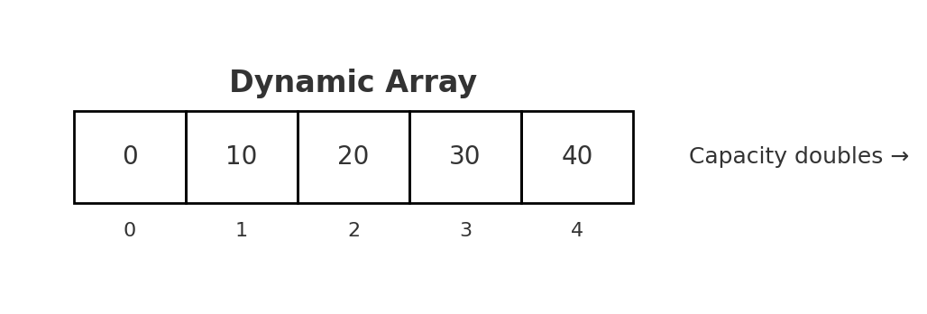 | This can be used in an image-editing program whereby there needs to be a list of recently used colors for a palette that the user can use without running out of space | At the beginning: O(n)  At the end: O(1) | Find by value: O(n)  Find by index: O(1)
Linked List (Doubly-linked) | 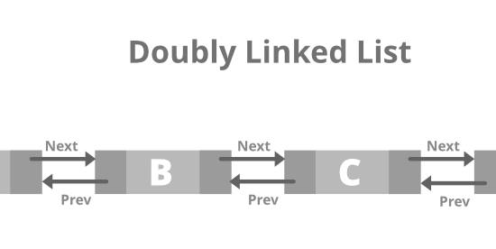 | A doubly linked list is a sequence of nodes where each node contains a data value and two pointers: one to the previous node and one to the next node. This allows traversal in both directions and efficient insertions or deletions at both ends. For example, a music player could store its playlist as a doubly linked list, allowing the user to quickly skip forward or backward between songs without shifting all elements. | At the beginning:  0(1)  At the end (01) | Find by value:0(n)  Find by index:0(n)
Stack | 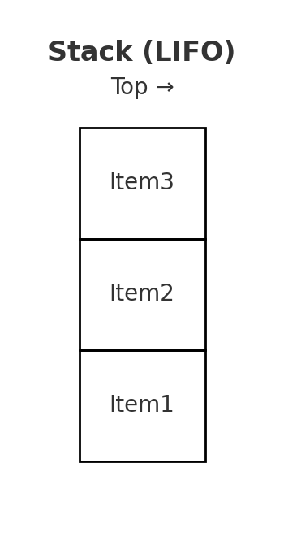 | A stack is a collection that follows the Last-In-First-Out (LIFO) principle. Elements are added and removed from the top of the stack only. This makes it useful for tasks such as undo functionality in applications, where the most recent action should be undone first. | 0(1) | The top: 0(1)
Queue | 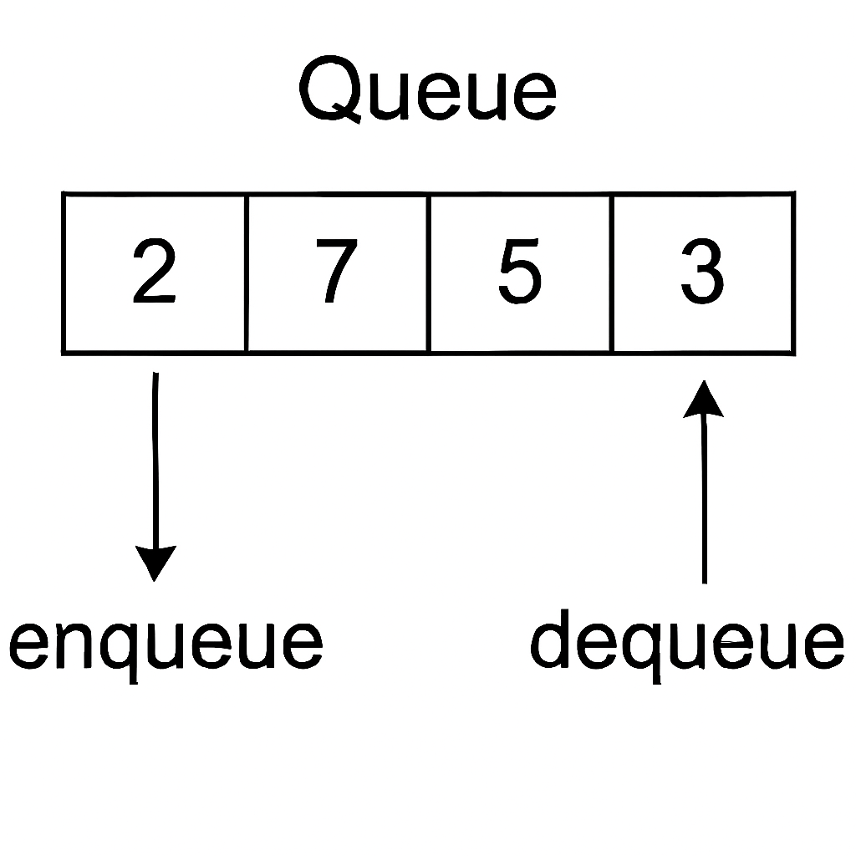 | A queue is a collection that follows the First-In-First-Out (FIFO) principle. Elements are added to the rear and removed from the front. For example, a printer queue can store documents in the order they are submitted, printing the oldest request first. | 0(1) | The front: 0(1)
Map | 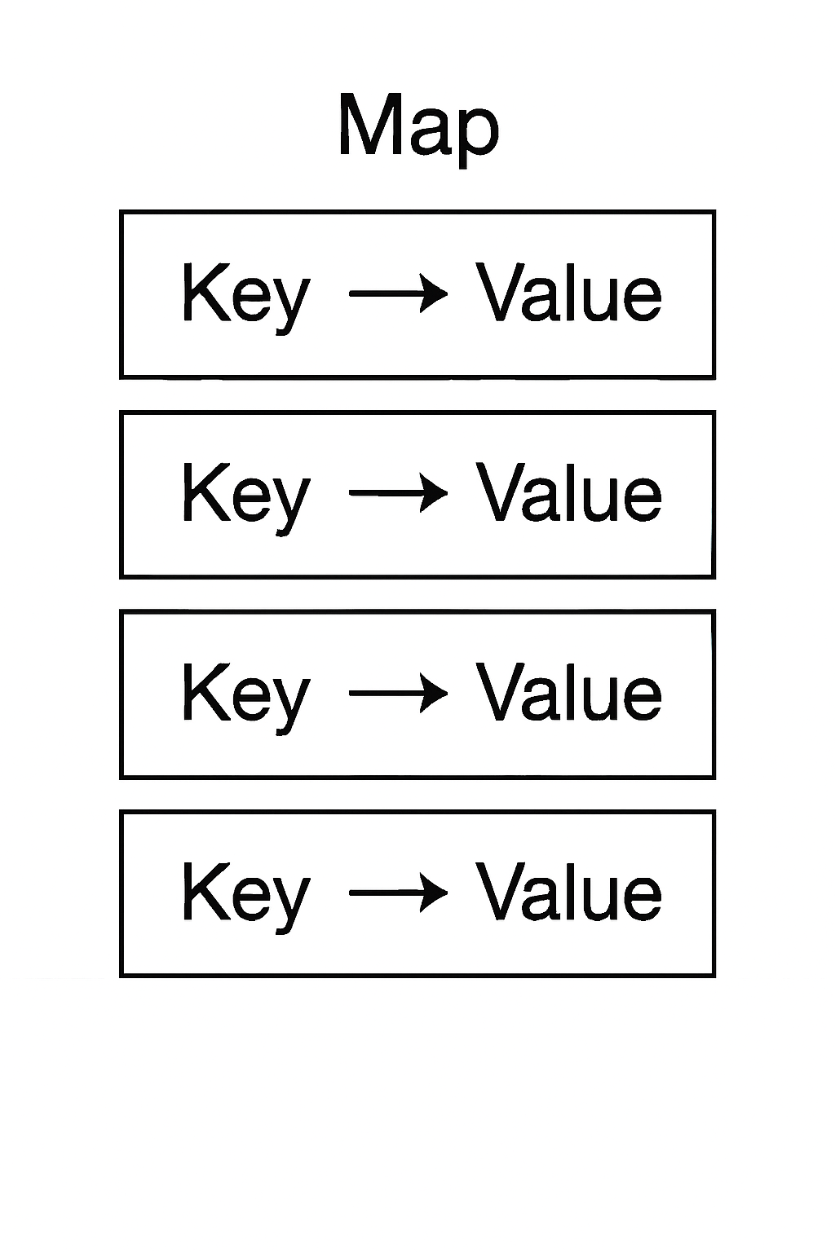 | A user login system where usernames are keys and passwords are values. The map allows quick verification of credentials.  ⏱️ Time Complexity of Common Operations | 0(n) | 0(n)
Balanced BST | 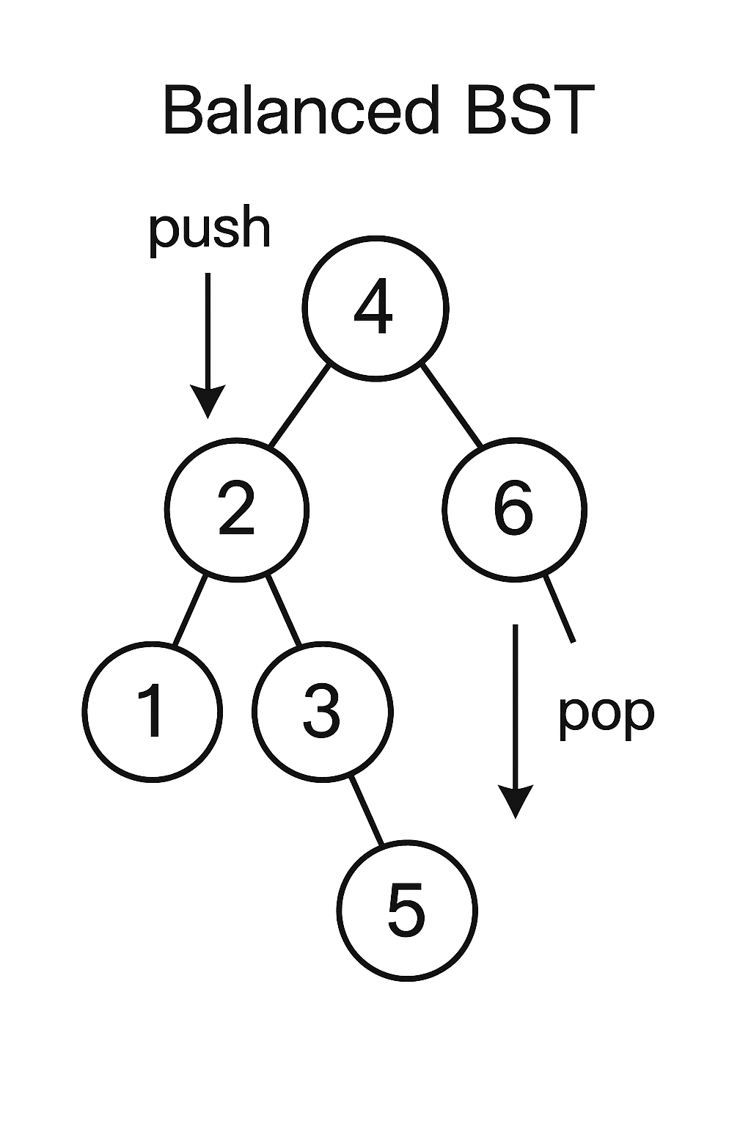 | A balanced binary search tree (BST) is a tree structure that maintains its height close to log(n) by automatically balancing itself after insertions and deletions. This ensures efficient searching, insertion, and deletion. For example, a game leaderboard could use a balanced BST to keep scores sorted while allowing quick lookups of player ranks. | O(log n) | O(log n)

